Suppose that you are given the following MASM data segment declarations:  
.data  
idNumber    BYTE     ?  
status      WORD     0  
list        DWORD    42 DUP(?)  
count       DWORD    ?  
  
The address of idNumber is **0x4E00**.  
What is the hexadecimal address of the 14th element of list?    
What is the hexadecimal address of count? 4EABh

Assume that **LO** and **HI** have already been assigned as constants with **LO < HI**, and **x** has been declared as **DWORD** in the data segment.  Also, Irvine's library is included, and***Randomize*** has already been called.  Which of the following code fragments will assign to **x** a "random" integer in the range **[LO .. HI]**? Check all that apply.

**Correct!**



mov    eax,HI  
sub    eax,LO  
inc    eax  
call   RandomRange  
add    eax,LO  
mov    x, eax



mov    eax,HI  
call   RandomRange  
mov    x,eax  
mov    eax,LO  
call   RandomRange  
sub    x,eax

**Correct!**



mov    eax,HI  
mov    ebx,LO  
dec    ebx  
sub    eax,ebx  
call   RandomRange  
add    eax,LO  
mov    x, eax



push    LO  
push    HI  
call    RandomRange  
pop     x

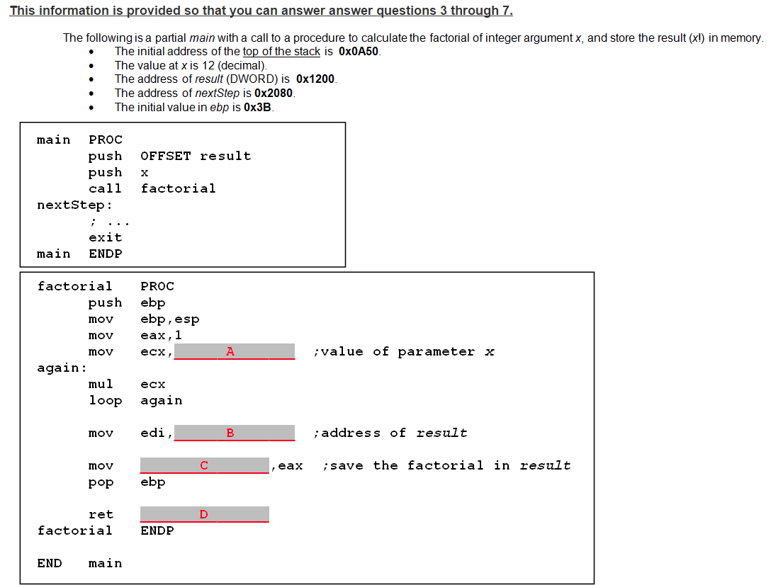

Please select the text that should be placed in the blank space labeled A.

  0x2080

[ebp+12]

[edi]

[ebp+8]

 Please select the text that should be placed in the blank space labeled B.

[ebp+8]

[edi]

[ebp+12]

0x2080

 Please select the text that should be placed in the blank space labeled C.

0x2080

[edi]

[ebp+12]

[ebp+8]

 Please select the number that should be placed in the blank space labeled D.

4

16

8

12

2

 What hexadecimal number will ESP contain when the "mov eax,1" instruction is executed?

**You Answered**



Based on the code given below, please show the ***decimal*** contents of the array after execution has completed.  
Array Contents:  
0x2200:    
0x2204:    
0x2208:    
0x220C: 

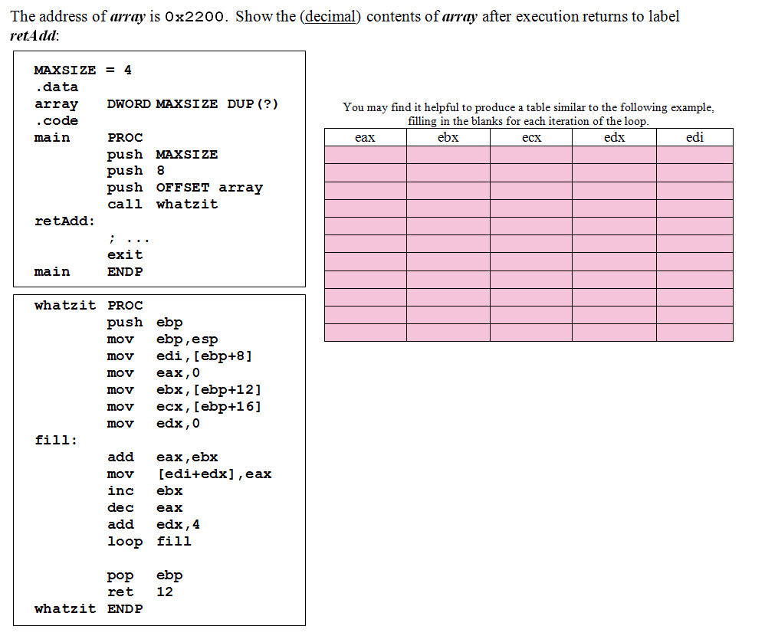

Which of the following postfix expressions corresponds to the given infix expression?

(13 + 14 - 3 + 2) / 2 ^ 3

**Correct!**

13 14 + 3 - 2 + 2 3 ^ /

13 14 + 3 2 - + 2 3 ^ /

13 14 + 3 2 + - 2 3 ^ /

13 14 + 3 - 2 + 2 3 / ^